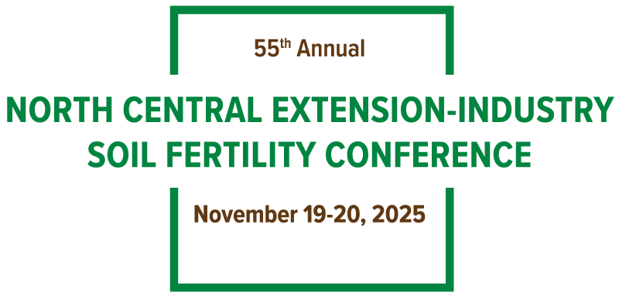

University Speaker and Poster Presentations Assignments List

Due via submission online by October 1, 2025

How to submit an abstract/paper: visit the conference website, http://northcentralfertility.com/ on the menu, choose abstract then choose speaker or poster. Read the basic instructions and download the example abstract/paper (Microsoft Word Document Only, NO PDF’S). Follow the link on this page to begin your speaker/poster abstract/paper. All abstracts/papers must be submitted using the website (not by email).

2025 Speaker Presentation  Kansas  Manitoba  Minnesota  Nebraska-Lincoln  Ohio  Ontario  Purdue  South Dakota | 2025 Poster Presentations  Iowa  University of Illinois  Kentucky  Michigan  Missouri  North Dakota  Southern Illinois University  Wisconsin

