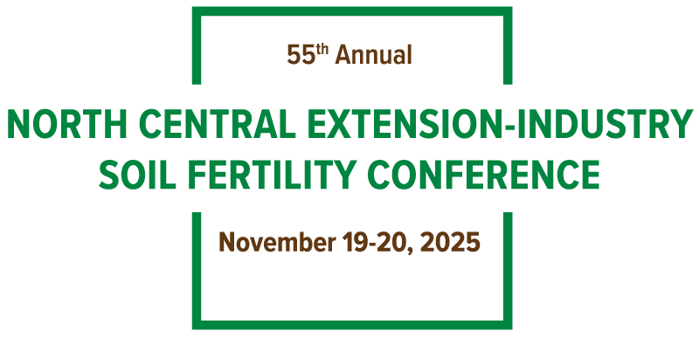

University Graduate Student Award Form
PLEASE RETURN THIS FORM TO MERSHON TOBIN, info@northcentralfertility.com BY

OCTOBER 1, 2025
Please complete this form for one qualifying graduate student from your state/province that you would like to receive the NCSFC Outstanding Graduate Student Award. It is suggested that each state conference representative discuss the nomination with their department’s faculty to ensure that all students working in the area of soil fertility are considered.

Student Requirements are:
- Must submit a poster abstract and proceeding paper by November 1, 2025 online at https://northcentralfertility.com
- Must provide a poster at the conference
- Must be present at your poster during all poster breaks and the Wednesday evening mixer
- Must be present at the Awards Banquet on Wednesday evening
- Must be present for pictures after Awards Banquet
Student Award is:
- Cash Prize
- Certificate
- Free conference registration

We will notify all student nominees on October 15th with more information.
Student Name: ________________________________________________________________________________

University: ___________________________________________________________________________________

Email: _______________________________________________________________________________________

