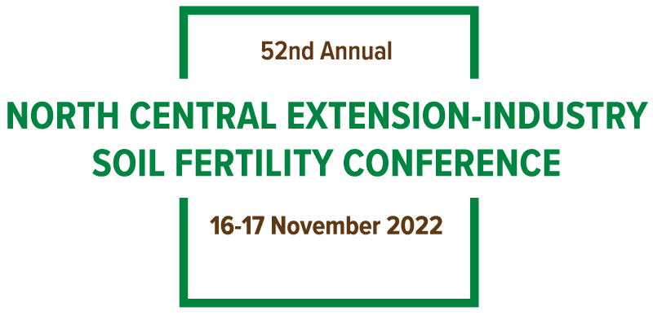

University Speaker and Poster Presentations Assignments List

Due via submission online by October 3, 2022
How to submit an abstract/paper: visit the conference website, http://northcentralfertility.com/ on the menu, choose abstract then choose speaker or poster. Read the basic instructions and download the example abstract/paper (Microsoft Word Document Only, NO PDF’S). Follow the link on this page to begin your speaker/poster abstract/paper. All abstracts/papers must be submitted using the website (not by email).
2022 Speaker Presentation  Iowa  Southern Illinois University  Kentucky  Michigan  Missouri  North Dakota  Wisconsin  Manitoba | 2022 Poster Presentations  Minnesota  Nebraska-Lincoln  Ontario  South Dakota  Purdue  Kansas  Ohio  University of Illinois

