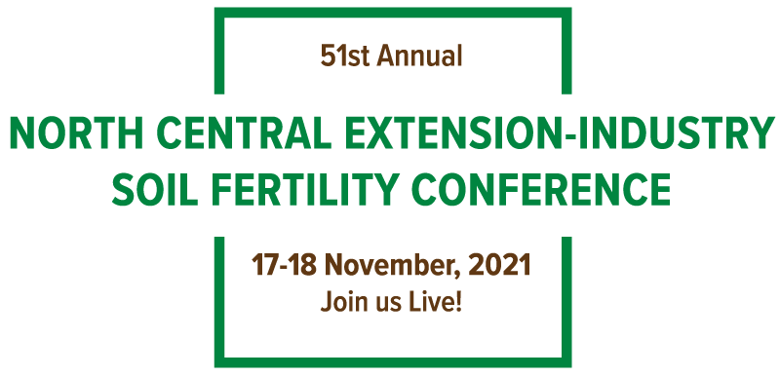

University Graduate Student Award Form
PLEASE RETURN THIS FORM TO MERSHON TOBIN, info@northcentralfertility.com BY

OCTOBER 1, 2021
Please complete this form for any qualifying graduate student(s) from your state/province that you would like to receive the NCSFC Outstanding Graduate Student Award. It is suggested that each state conference representative discuss the nomination with their department’s faculty to ensure that all students working in the area of soil fertility are considered.

Student Requirements are:
- Must submit a poster-proceedings abstract/paper by October 1, 2021 online at https://northcentralfertility.com
- Must provide a poster (maximum 4x4) at the conference for judging
- Must be present at your poster during all poster breaks
- Must be present during the entire two-day conference
- Must be present at the Awards Banquet
- Must be present for pictures after Awards Banquet
Student Name (#1):
__________________________________________________________
University: __________________________________________________________
Phone: __________________________________________________________
Email:
__________________________________________________________

- Must be present at the Student Social

Student Award is:
- Cash Prize
- Certificate
- Free conference registration

We will notify all student nominees on October 15th with more information.

